# EXPLORE TOP YOU TUBE CHANNEL

1. INTRODUCTION

YouTube channel was all people are most used one of the application,they are world and country wise

Channel was most subscribed country and rank,channel,we are obtained these are most useful to the

Knowledge and improving skills.

* 1. OVERVIEW

We are provide a explore top you tube channel and they are public showing sheets,dashboard,story are then project look like very useful to learn analytics.

* 1. PURPOSES

These purposes are improving analytic knowledge and they are identifying the top most channel and country ,languages.

1. PROBLEM STATEMENT & DESIGN THINKING

In this project they are understanding the many more graphically analytic and very useful to tableau and designing are colour,shapes,they are applying the projects.

* 1. EMPATHY MAP

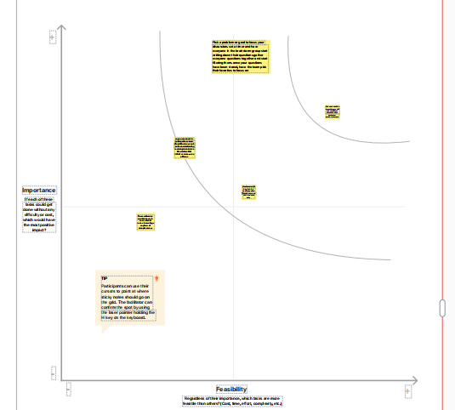

* 1. IDEATION AND BRAINSTORMING MAP

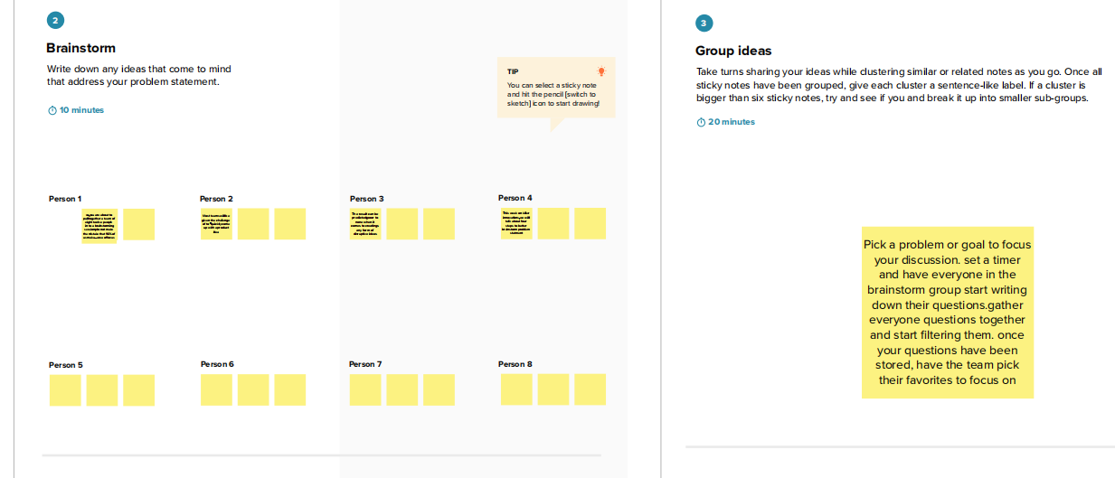

1. RESULT

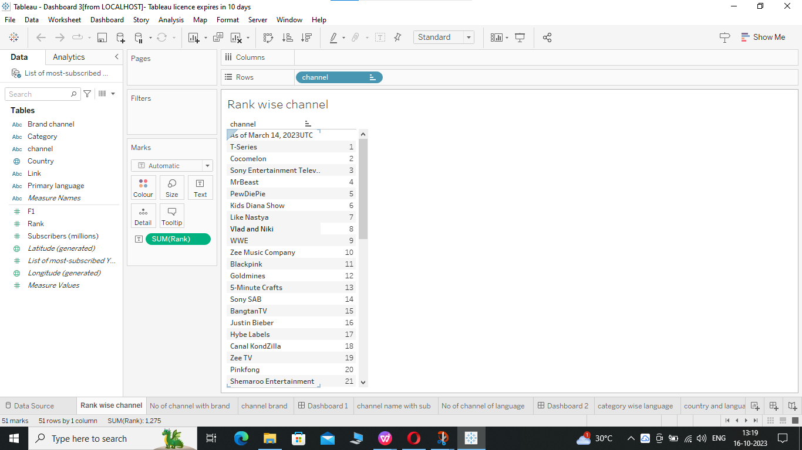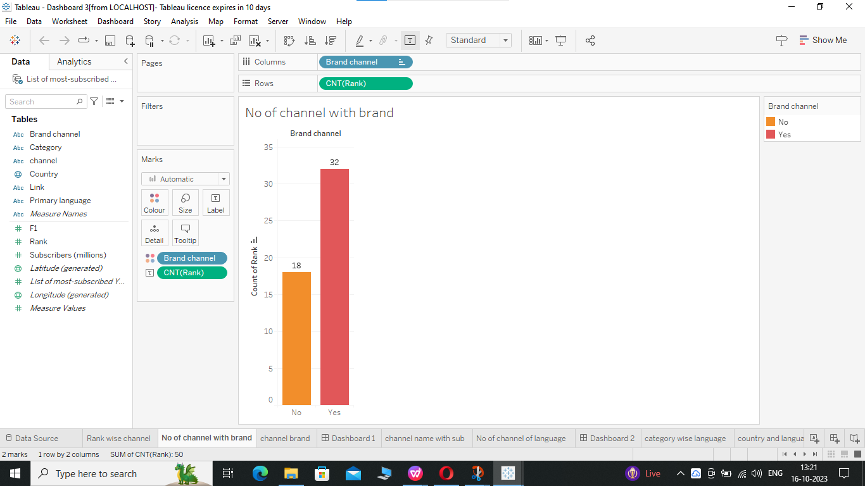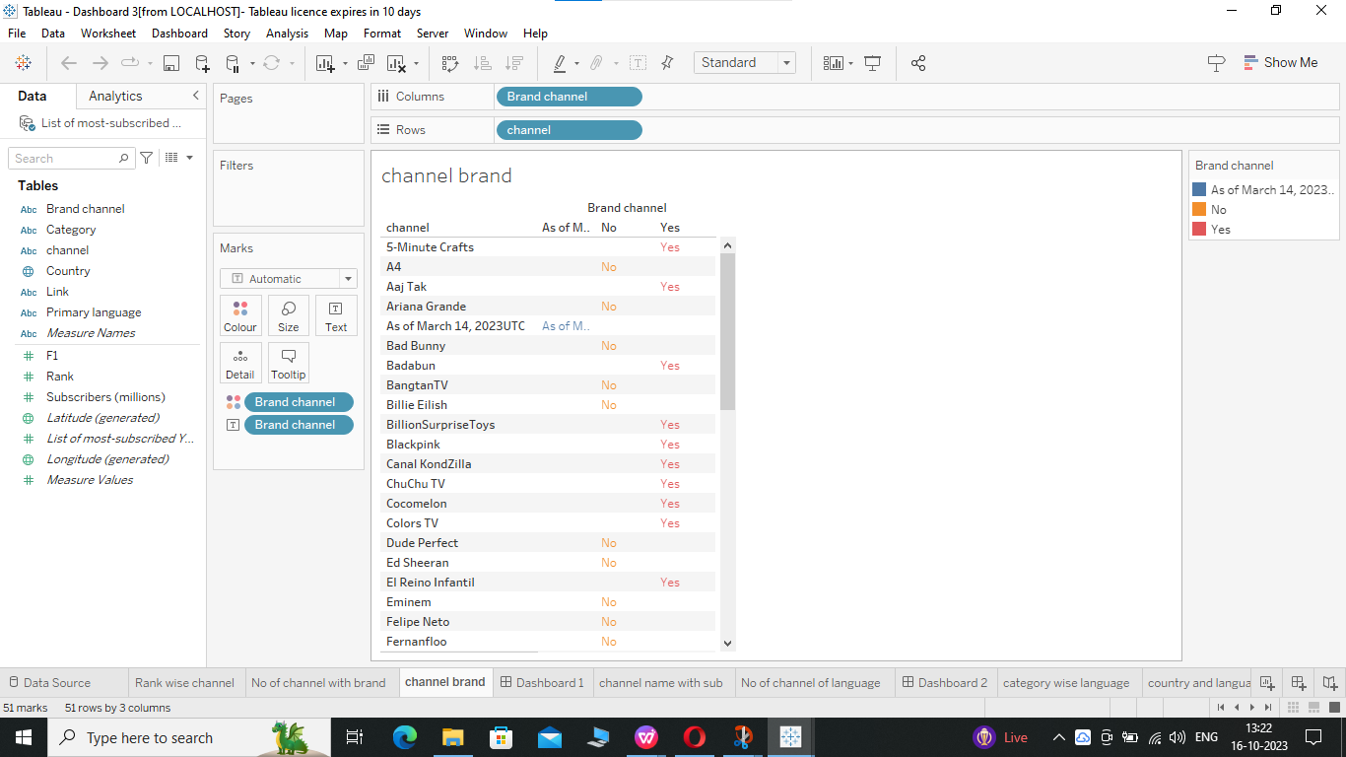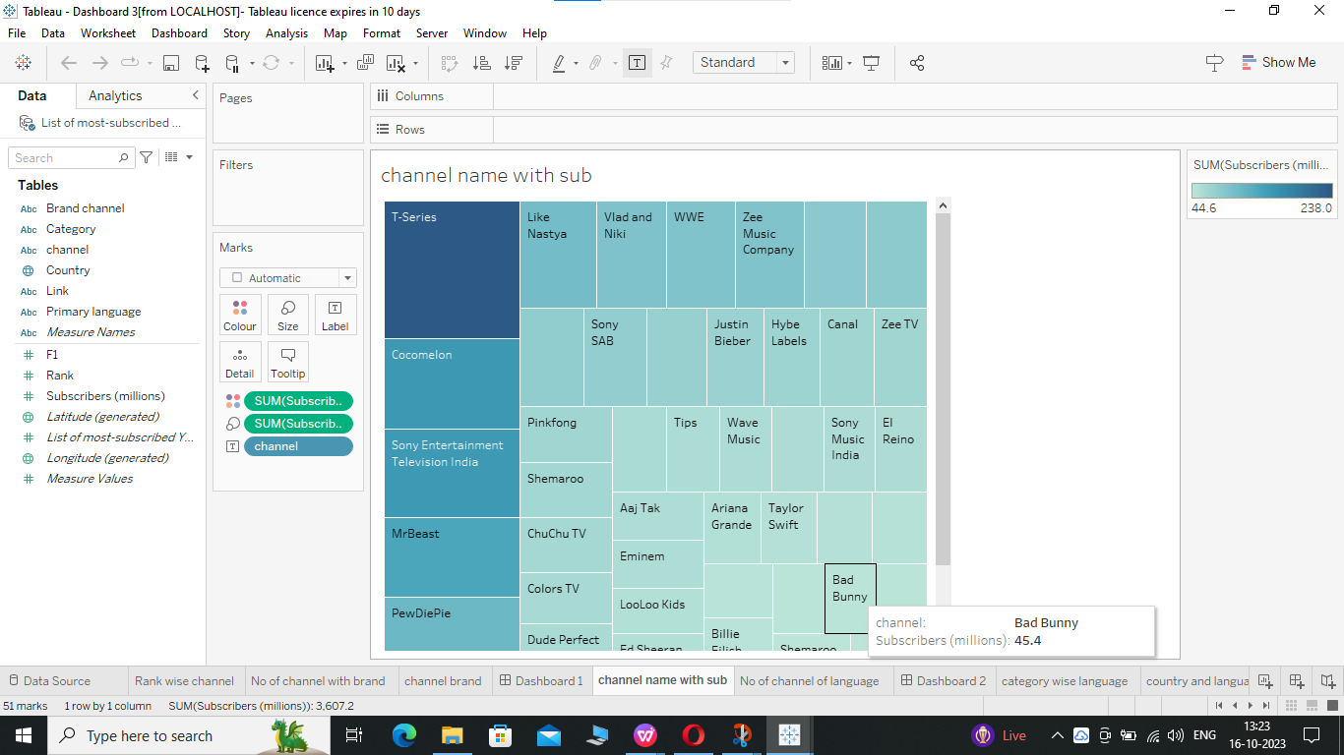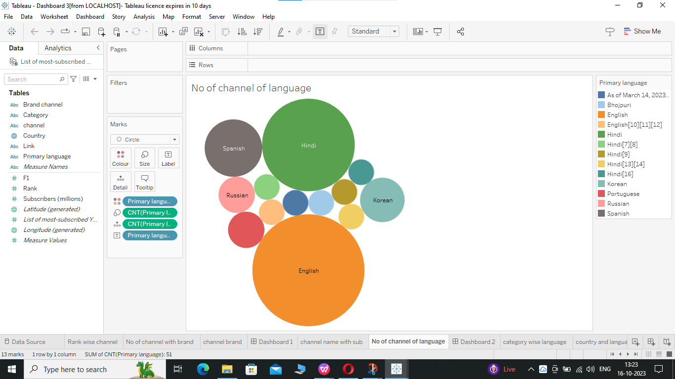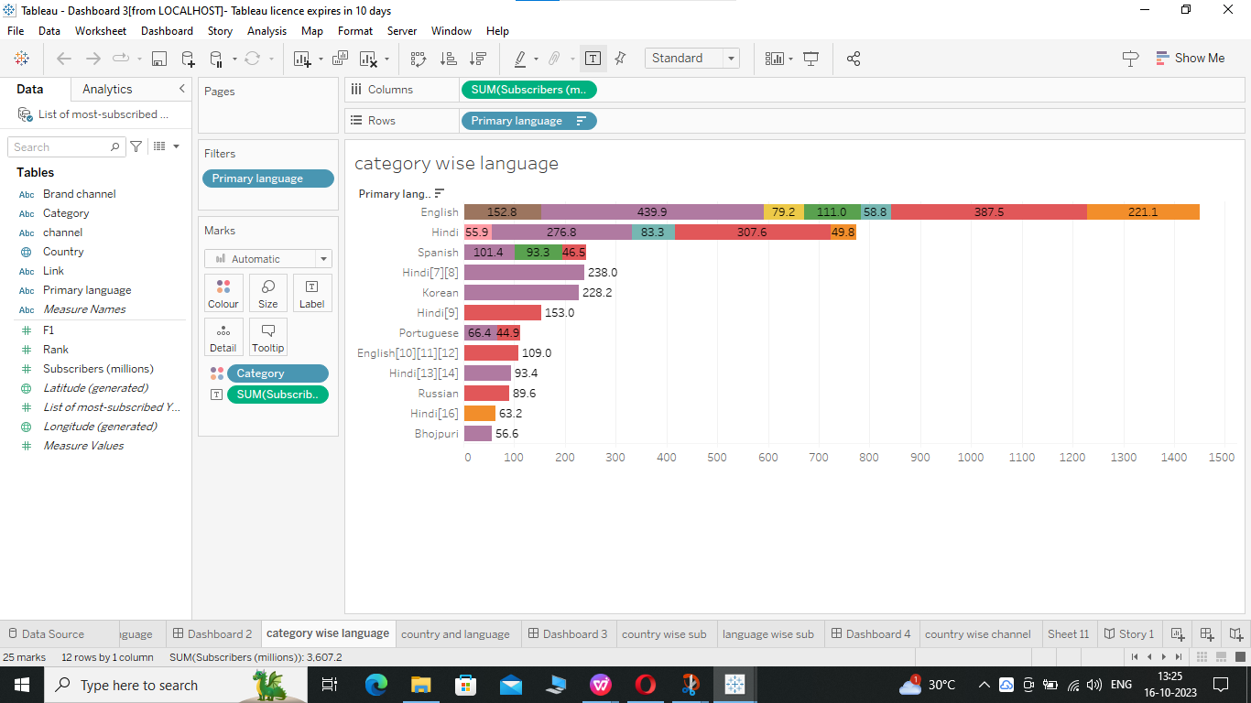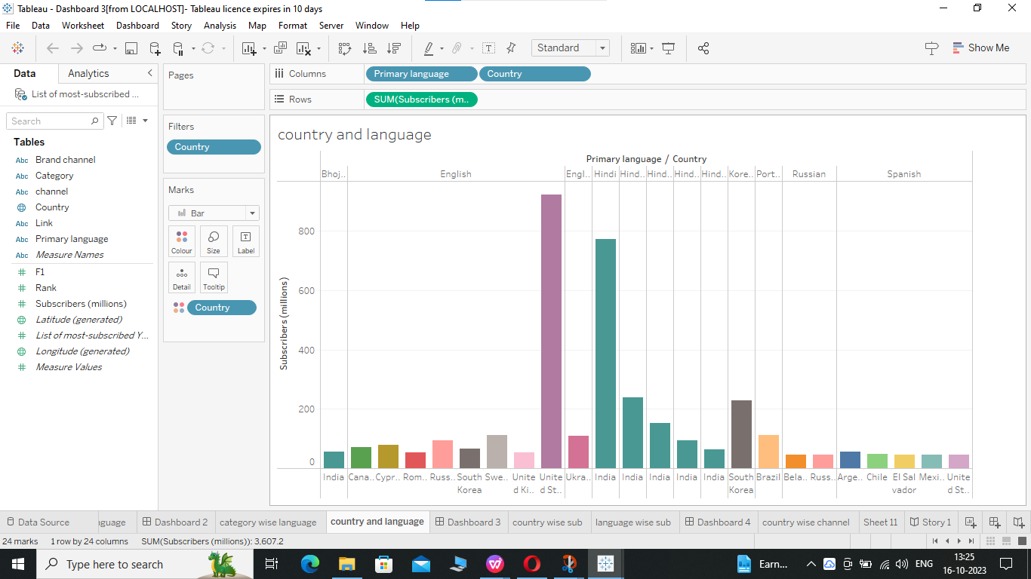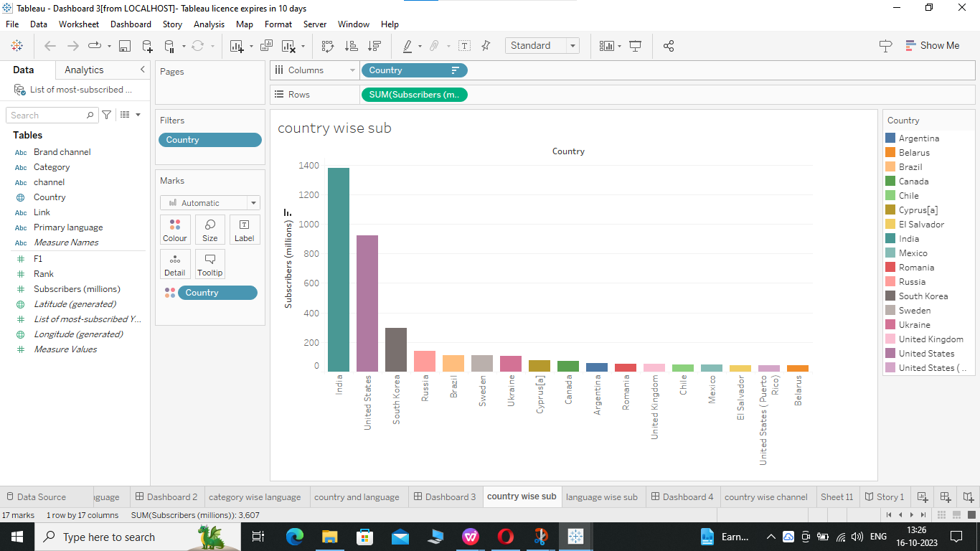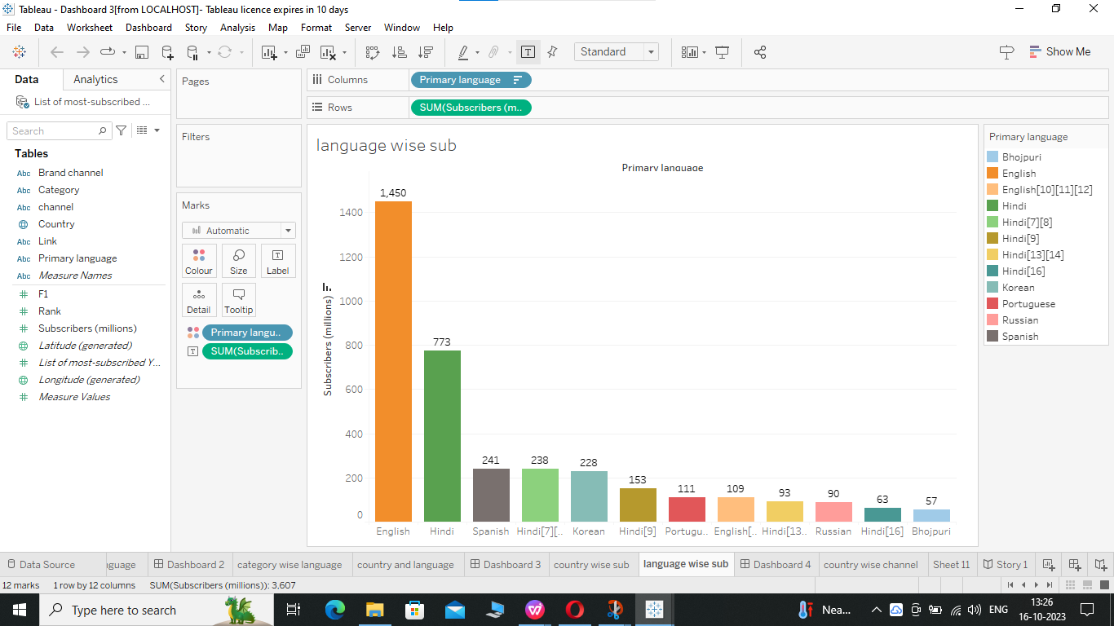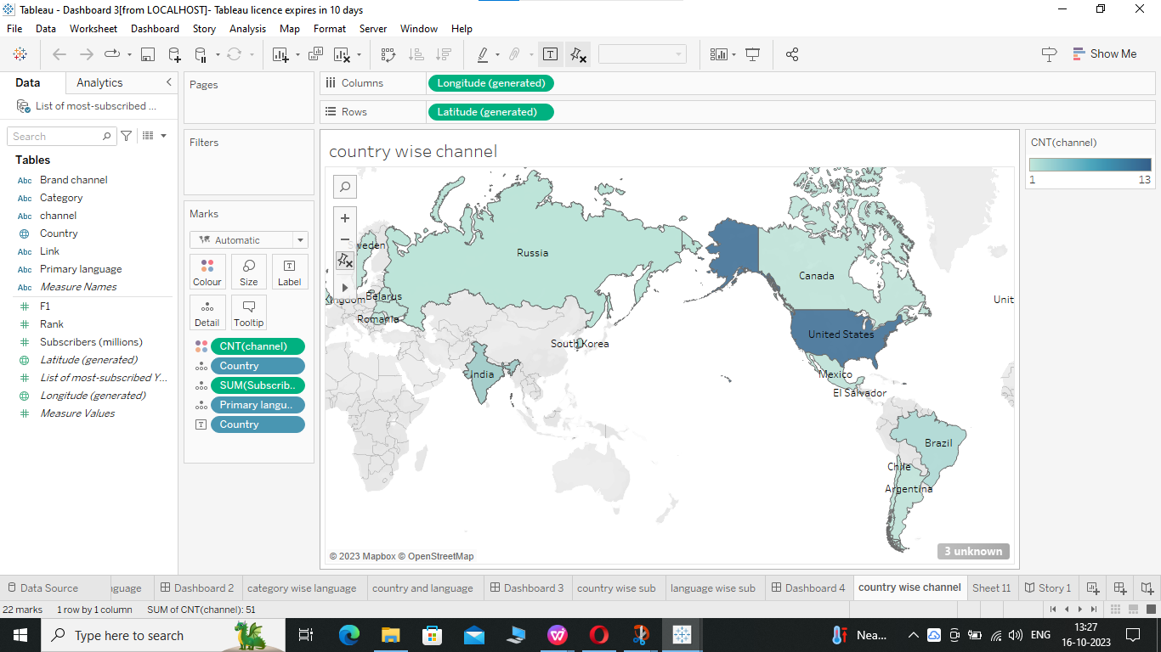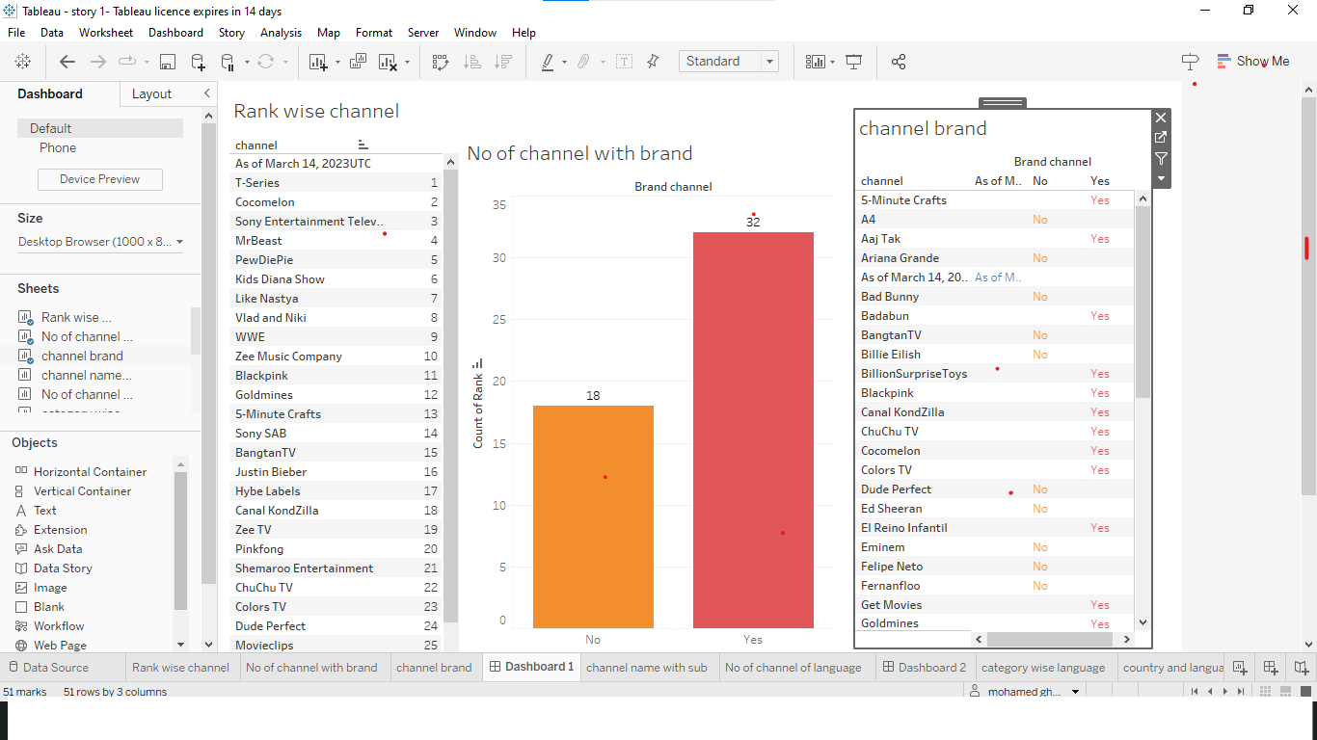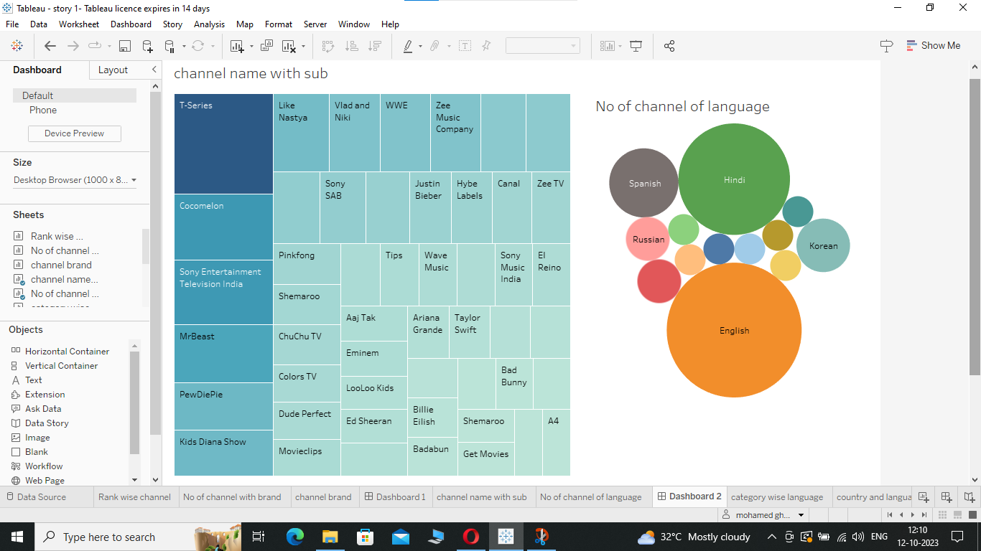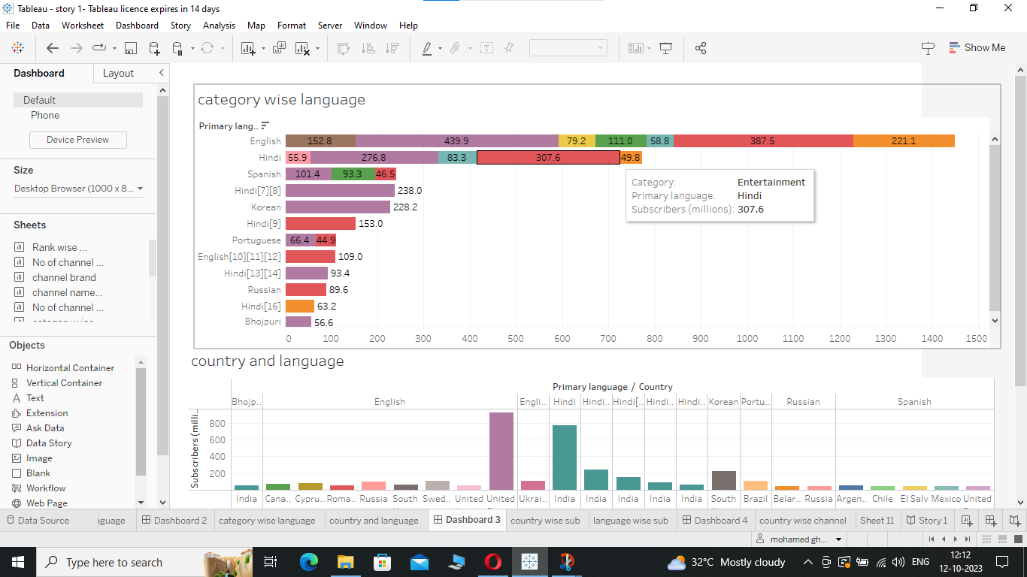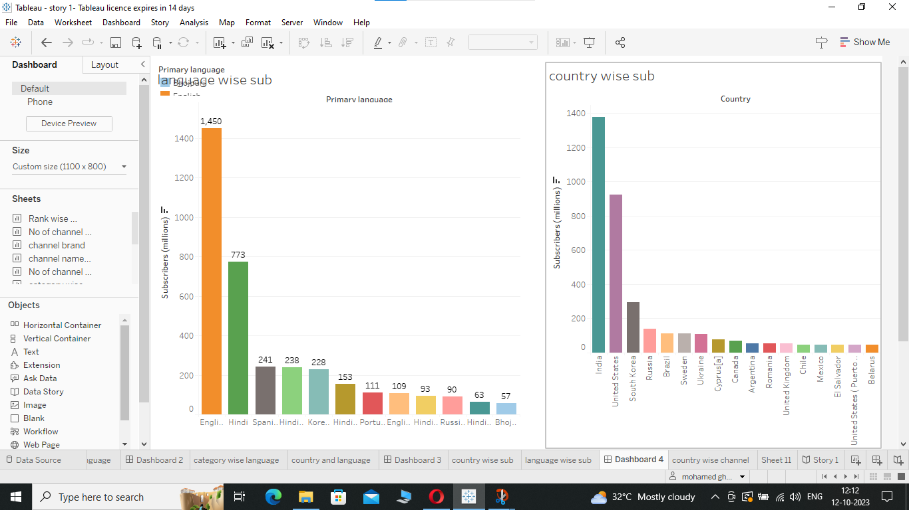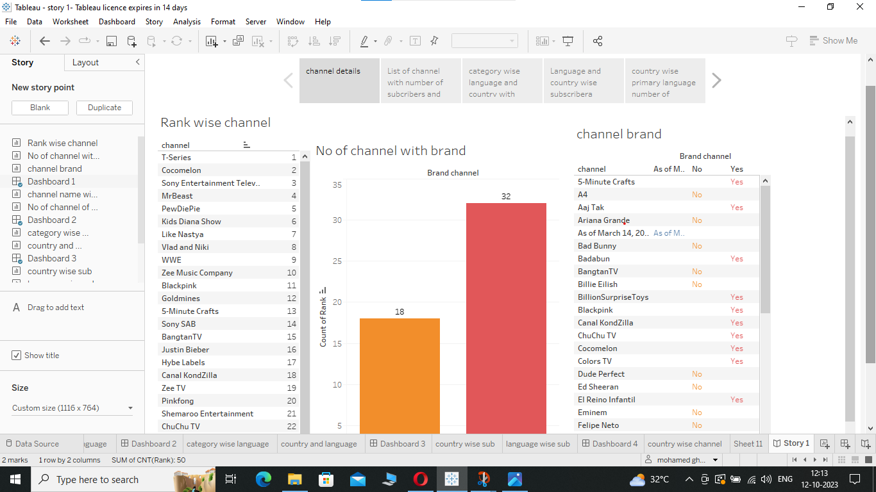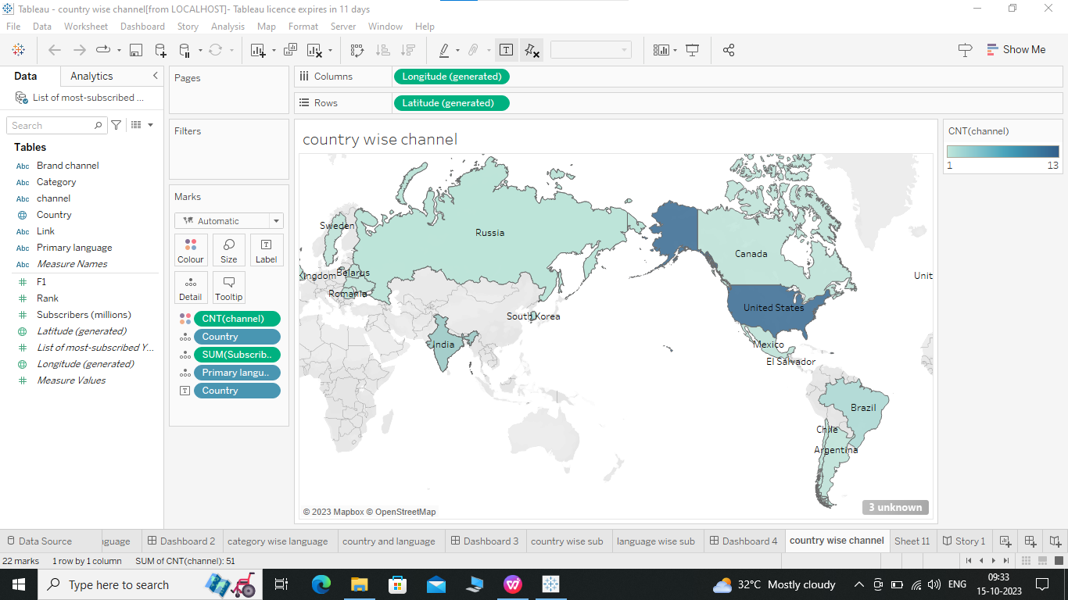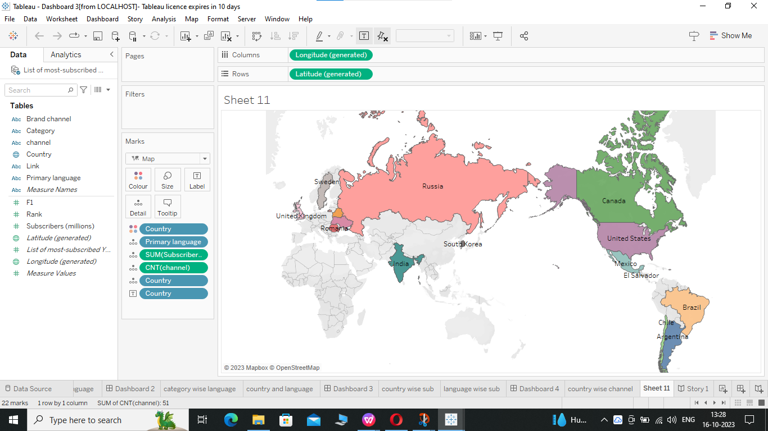

1. ADVANTAGES AND DISADVANTAGES

Advantages is I’m understanding the analytics graphs and youtube channel to explore

Disadvantages is no

1. APPLICATION

They are more developed youtube channels so both destroying to understanding and self improving knowledge's and we can provide channels and many types of languages,country.

1. CONCLUSION

List of most subscribed you tube channel was my team was understanding the graphical analytic to collect the data sets and put the dashboard1,2,3,4 and story we are obtained the country wise channel,sheet11.

1. FUTURE SCOPE

The scope is well learned analytic full of studies are beginners will be taken easily to understand so they are this project was very useful to learning

THANKING YOU